

Tel 82-2-2675-5700 Fax 82-2- 2675-0576
mailto:tmc@tmc.co.kr
home-page;http://tmc.co.kr/

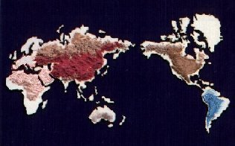

Titanium Dioxide (TMC BA-100), Anatase

Physical properties
Formula TiO₂
Molecular weight 79. 9
Appearance White Powder
Screen Size 325 mesh. 99.90% pass.

Specification

Component | Unit | Guaranteed  Analysis
TiO2 | % | 98.5 % min
Fe2O3 | % | 0.01 % max
H2O | % | 0.30 % max
Residue(325 mesh) | % | 0.10 % max
Whiteness | % | 97.00 % min
Oil Absorption | cc/100g | 22 max
Particle Size | μm | 0.33
Lightening Power | % | 105
Ignition Loss | % | 0.3 % max
Matter soluble in Water | % | 0.6 max
pH |  | 7.0~7.4
CHROMA |  | CB0.5~CR0.5
Dispersion rate( in water) | % | 70.0 % min
Lead (Pb) | ppm | 20
Cadmium(Cd) | ppm | 10
Arsenic (As) | ppm | 2

Packing
25kg Paper bag, or 500 kg Jumbo bag.

